# **Task 2**

Student Name: Shreyas Bharadwaj Nidaghatta Ravi

Student ID: 11645440

Email: [shreyasnr6666@gmail.com](mailto:shreyasnr6666@gmail.com)

Lecture Name: Recep Ulusoy

**UML Activity Diagram:**

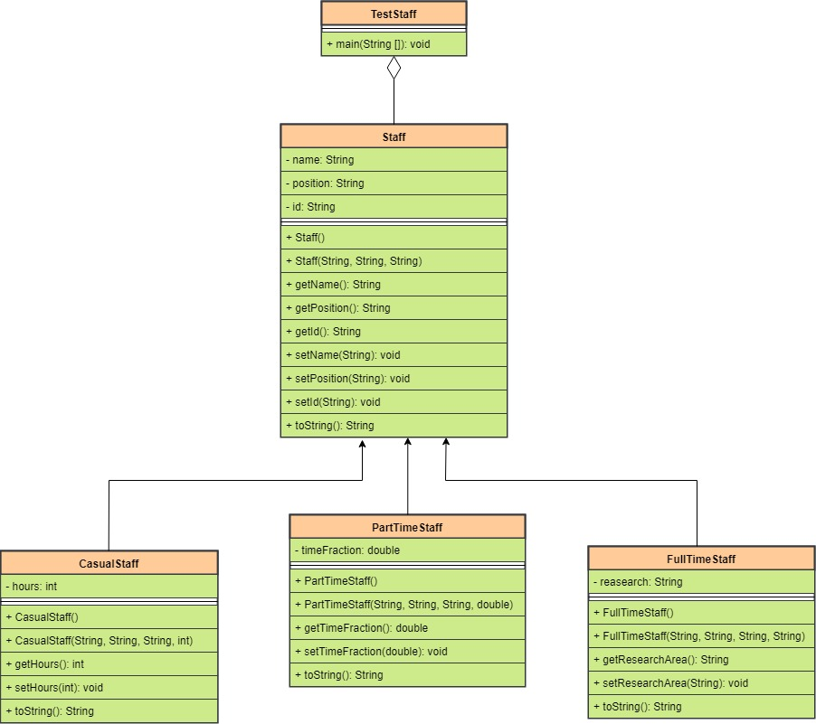

**Program Logic:**

In CasualStaff class, we have created constructors, getters and setters. This class will inherits the Staff class which is abstract class which have an abstract method which will be overridden in the classes that will inherit this.

Same logic will be used for FullTimeStaff and PartTimeStaff. All the functions will be changed accordingly.

Staff class is the base class of all the classes which will have constructor, setters and getters and an abstract method.

In testStaff class, We have read all the data from the text file(staff.txt) using while loop. We have stored all the data into the arraylist of staff object. After that do-while loop has been used for display the menu and taking user’s option. If-else statements have been used to perform task according to the choice selected. In if-else statements, we have checked the name of the class using getClass(). Loop will be terminated after selecting quit option.

**Screenshots:**

Menu display:

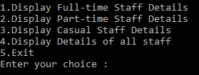

Choice 1:

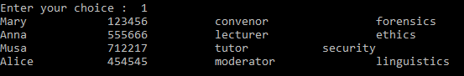

Choice 2:

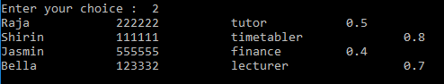

Choice 3:

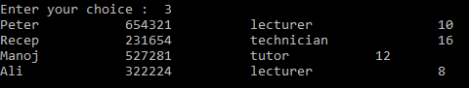

Choice 4:

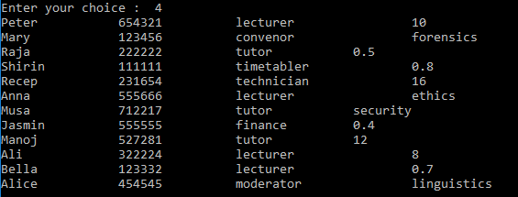

Choice 5:

